Deploy React App

Deploy React App in a docker container using Jenkins in the same EC2 instance

- Create a EC2 instance t2 medium amazon linux
- Login as ec2-user and Install git, Jenkins, Docker, Node.js
- Add Plugins “Node JS Plugin” and “Multi Branch Scan Webhook Trigger” in Jenkins and configure it under tools section.
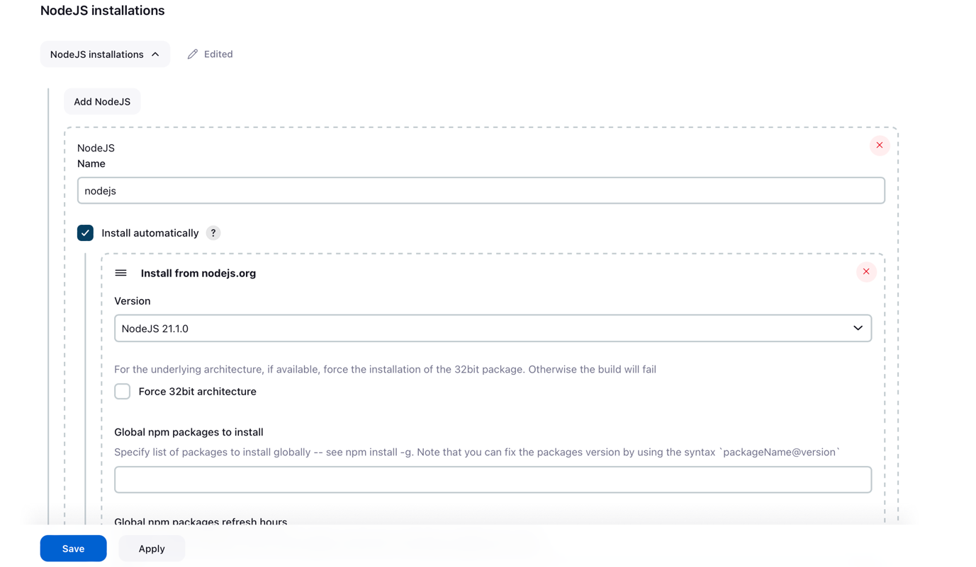
- Create a react project or fork the existing project.
- Add Dockerfile and Jenkinsfile with the content.
- Create a multi branch pipeline configure
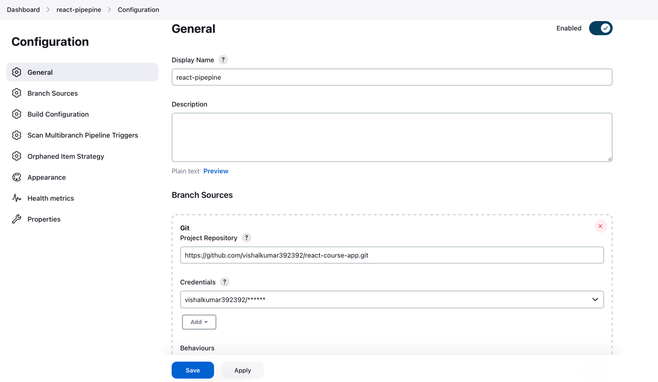

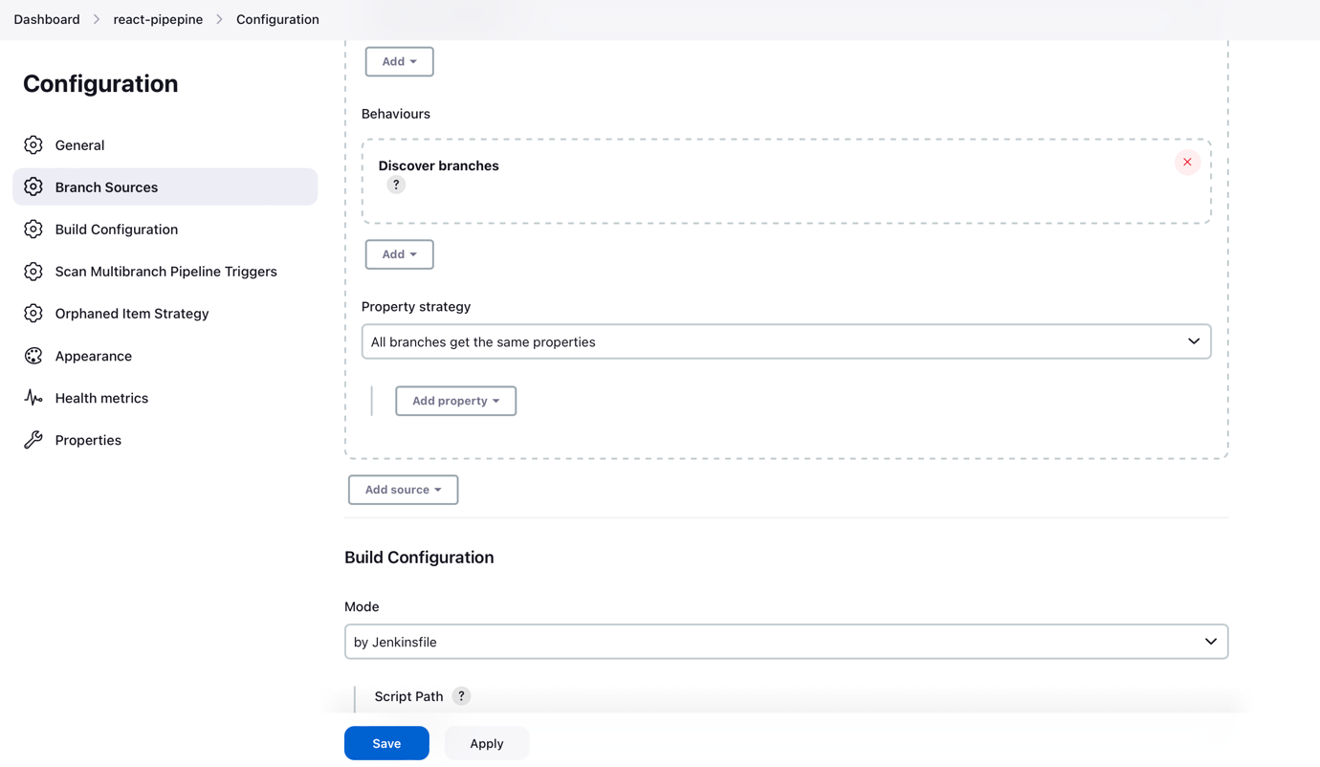

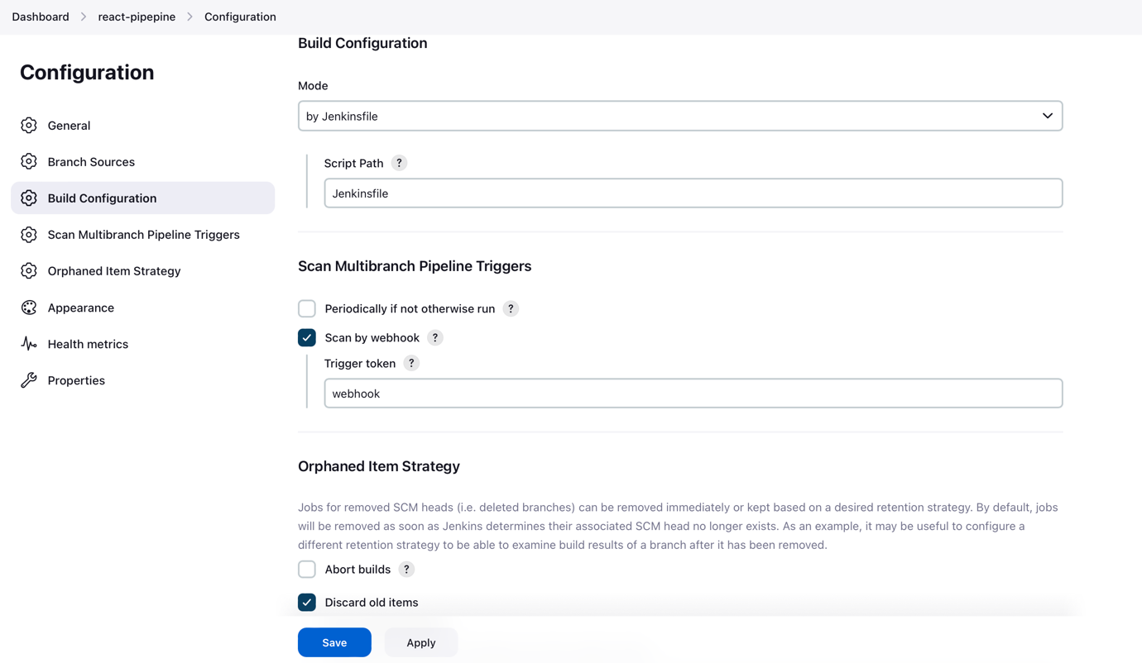

- Add a webhook in the github under your repo. “http://<Jenkins public IP:8080>/multibranch-webhook-trigger/invoke?token=webhook”

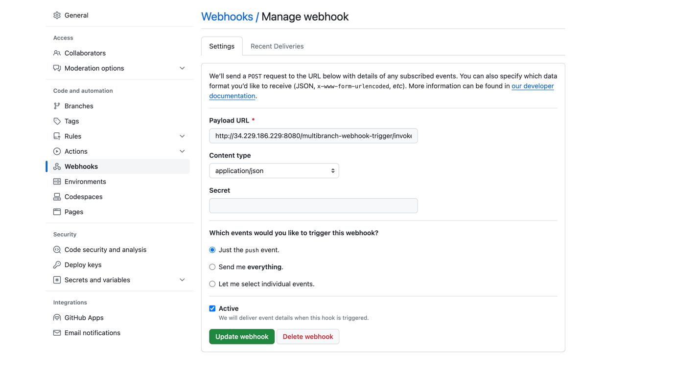

- Build the pipeline manually or by pushing some code.
- We are Done.

